Assignment # 1 (Deadline 28/October/2025 – 11:50pm)
~~~~~~~~~~~~~~~~~~~~~~~~~~~~~~~~~~~~~~~~~~~~~~~~~~~~~~~~~~~~~
Note:
- Assignment should be hand written and converted to pdf or word before submitting it on portals.
- Typed assignment will get -2.5 marks as penalty.
- Assignment submitted after deadline but within 24 hours will get -2.5 marks as penalty.
- Assignment submitted after 24 hours but before 48 hours will get -5 marks as penalty.
- Assignment submitted after 48 hours will get 00 marks.
- Plagiarized assignments will get 00 marks.
Part 1
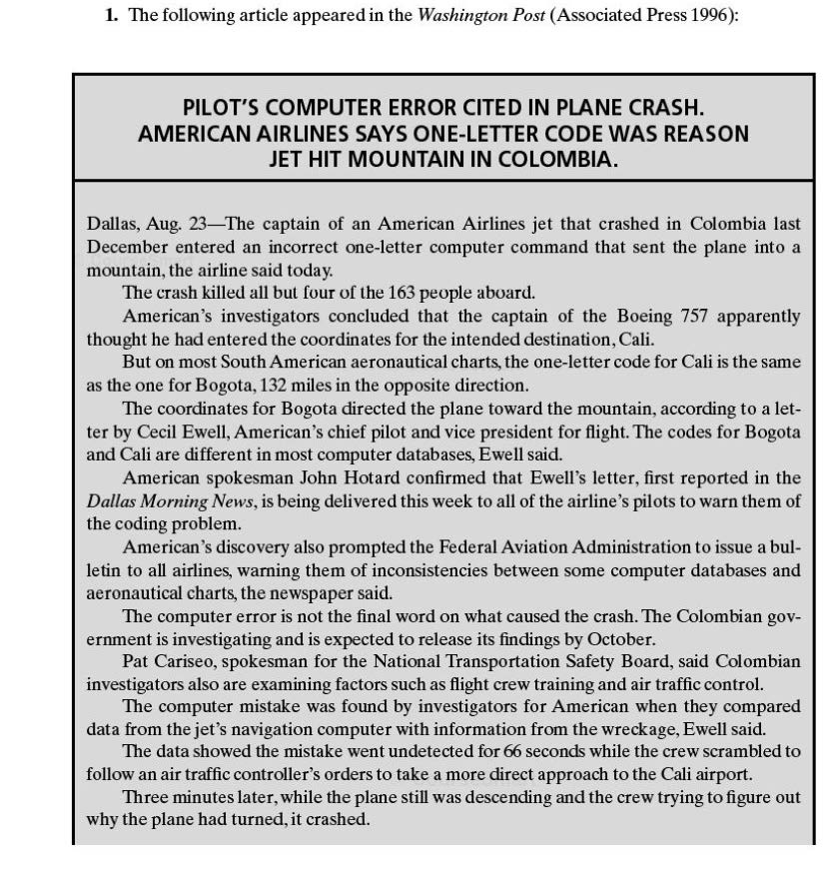
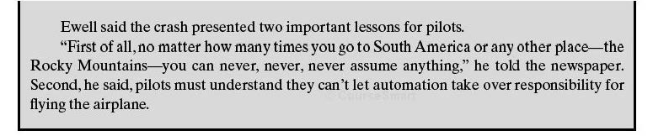

Question 1) Is this article evidence that we have a software crisis?

Question 2) How is aviation better off because of software engineering?

Question 3) What issues should be addressed during software development so that problems like this will be prevented in the future?

Part 2

- Waterfall model
- Waterfall model with prototyping
- Prototyping model
- V model
- Phased Development
- Spiral Model
- Unified Process Modeling
- Extreme Programming
- Scrum

Question: Answer all 3 questions for each of the process models mentioned.

1. Give 02 benefits of using the model?
2. Give 02 drawbacks of using the model?
3. How does the model handle a significant change in requirements, late in the development?

~~~~~~~~~~BEST OF LUCK~~~~~~~~~~

